SYNTAX
print("Hello, World!")
Hello, World!

if 5 > 2:
print("Five is greater than two!")

if 5 > 2:
print("Five is greater than two!")
if 5 > 2:
print("Five is greater than two!")

if 5 > 2:
print("Five is greater than two!")
print("Five is greater than two!")

x = 5
y = "Hello, World!"

#This is a comment.
print("Hello, World!")

print("Python is fun!")

PRINT

print("Hello World!")

print("Hello World!")
print("I am learning Python.")
print("It is awesome!")
print("This will work!")
print('This will also work!')

print("Hello World!", end=" ")
print("I will print on the same line.")
print(3)
print(358)
print(50000)

print(3 + 3)
print(2 * 5)
print("I am", 35, "years old.")

#print("Hello, World!")
print("Cheers, Mate!")

VARIABLES
x = 5
y = "John"
print(x)
print(y)
x = 4 # x is of type int
x = "Sally" # x is now of type str
print(x)

x = str(3) # x will be '3'
y = int(3) # y will be 3
z = float(3) # z will be 3.0
x = 5
y = "John"
print(type(x))
print(type(y))

x = "John"
# is the same as
x = 'John'

myvar = "John"
my_var = "John"
_my_var = "John"
myVar = "John"
MYVAR = "John"
myvar2 = "John"

x, y, z = "Orange", "Banana", "Cherry"
print(x)
print(y)
print(z)
x = y = z = "Orange"
print(x)
print(y)
print(z)
fruits = ["apple", "banana", "cherry"]
x, y, z = fruits
print(x)
print(y)
print(z)
x = "Python is awesome"
print(x)

x = "Python"
y = "is"
z = "awesome"
print(x, y, z)
x = "Python "
y = "is "
z = "awesome"
print(x + y + z)
x = 5
y = 10
print(x + y)

x = "awesome"
def myfunc():
print("Python is " + x)
myfunc()

x = "awesome"
def myfunc():
x = "fantastic"
print("Python is " + x)
myfunc()
print("Python is " + x)

DATA TYPES
x = 5
print(type(x))
x = 1 # int
y = 2.8 # float
z = 1j # complex
print(type(x))
print(type(y))
print(type(z))
x = 1
y = 35656222554887711
z = -3255522
print(type(x))
print(type(y))
print(type(z))
x = 1.10
y = 1.0
z = -35.59
print(type(x))
print(type(y))
print(type(z))
x = 35e3
y = 12E4
z = -87.7e100
print(type(x))
print(type(y))
print(type(z))

x = 3+5j
y = 5j
z = -5j
print(type(x))
print(type(y))
print(type(z))

x = 1 # int
y = 2.8 # float
z = 1j # complex
#convert from int to float:
a = float(x)
#convert from float to int:
b = int(y)
#convert from int to complex:
c = complex(x)
print(a)
print(b)
print(c)
print(type(a))
print(type(b))
print(type(c))

x = int(1) # x will be 1
y = int(2.8) # y will be 2
z = int("3") # z will be 3

x = float(1) # x will be 1.0
y = float(2.8) # y will be 2.8
z = float("3") # z will be 3.0
w = float("4.2") # w will be 4.2

x = str("s1") # x will be 's1'
y = str(2) # y will be '2'
z = str(3.0) # z will be '3.0'

STRINGS
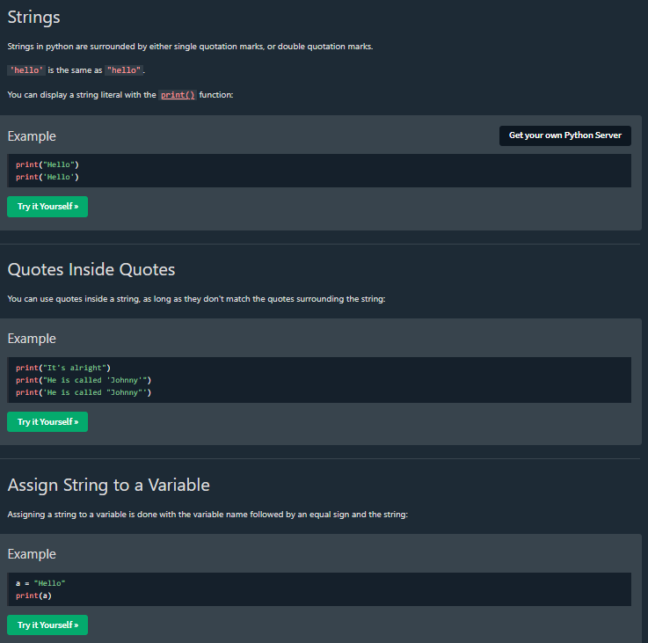

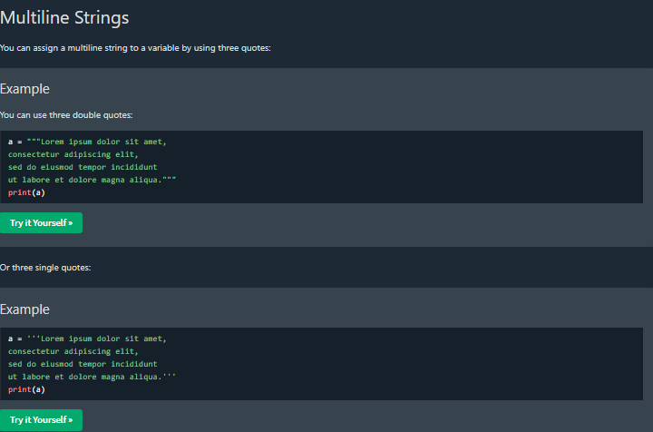

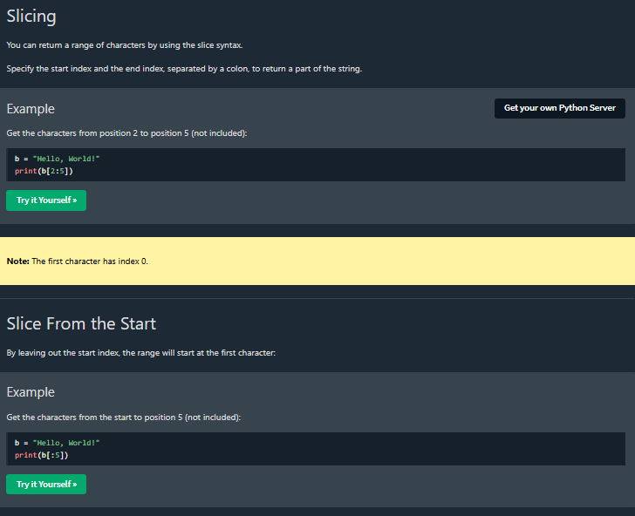
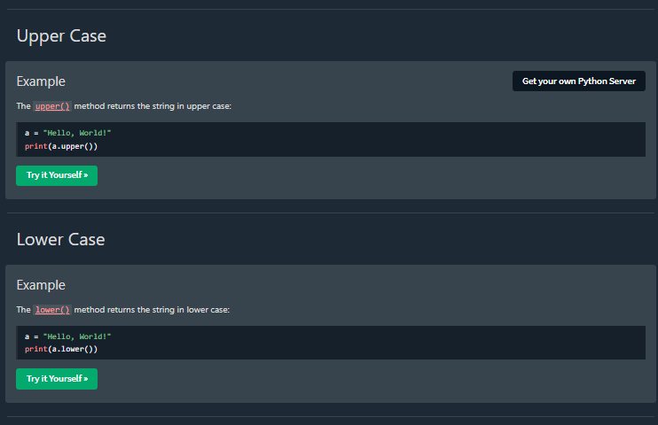

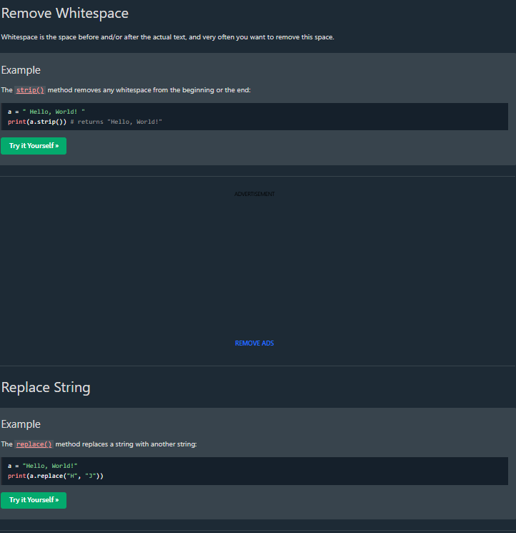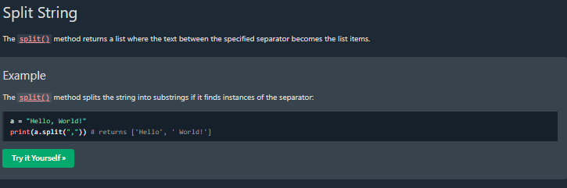

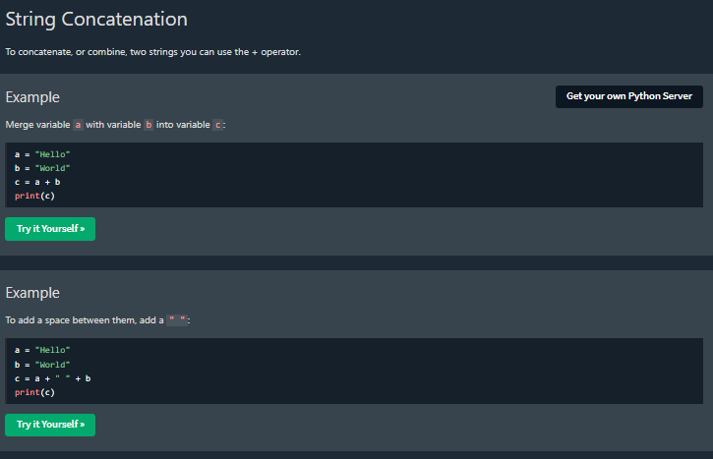
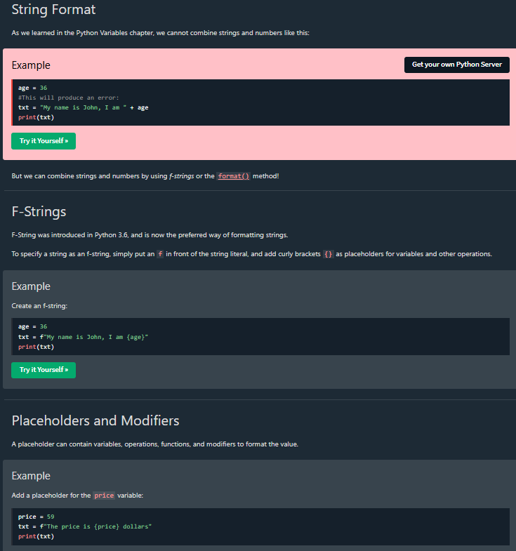

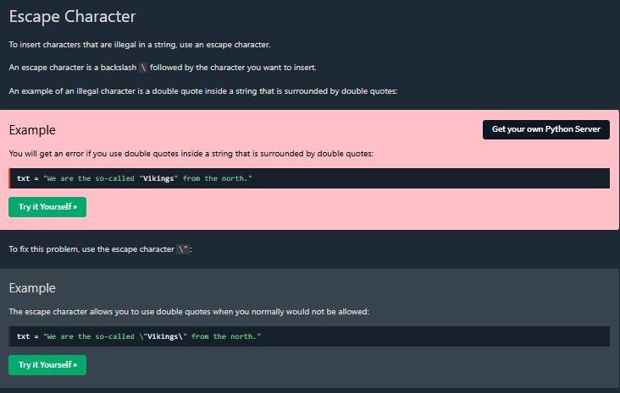
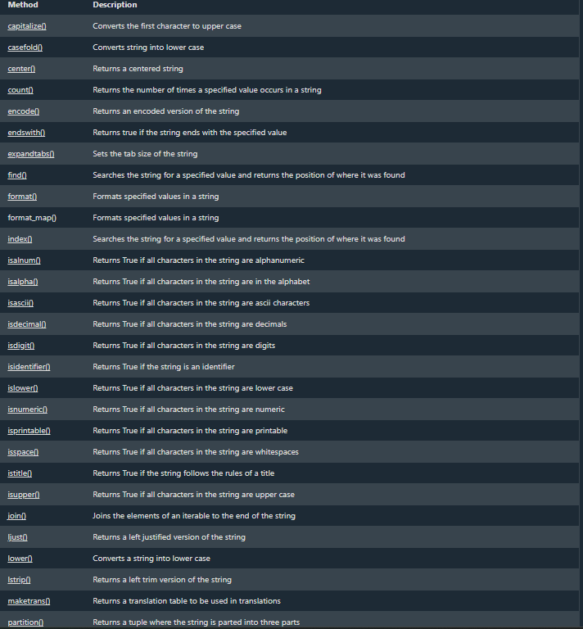

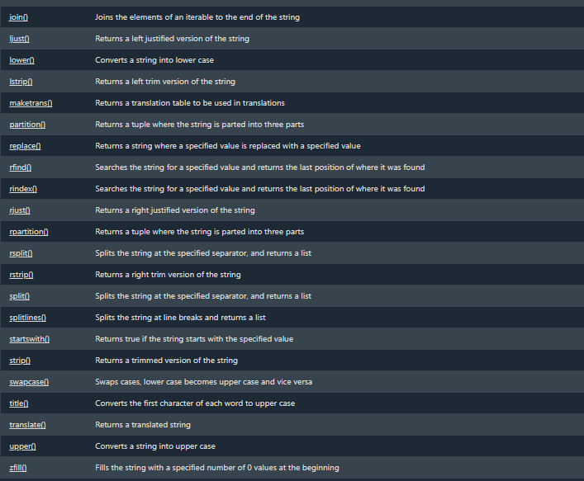

BOOLEANS
print(10 > 9)
print(10 == 9)
print(10 < 9)

a = 200
b = 33
if b > a:
print("b is greater than a")
else:
print("b is not greater than a")

print(bool("Hello"))
print(bool(15))

x = "Hello"
y = 15
print(bool(x))
print(bool(y))
bool("abc")
bool(123)
bool(["apple", "cherry", "banana"])

bool(False)
bool(None)
bool(0)
bool("")
bool(())
bool([])
bool({})
class myclass():
def __len__(self):
return 0
myobj = myclass()
print(bool(myobj))

def myFunction() :
return True
print(myFunction())
def myFunction() :
return True
if myFunction():
print("YES!")
else:
print("NO!")
x = 200
print(isinstance(x, int))

OPERATORS
print(10 + 5)
sum1 = 100 + 50 # 150 (100 + 50)
sum2 = sum1 + 250 # 400 (150 + 250)
sum3 = sum2 + sum2 # 800 (400 + 400)
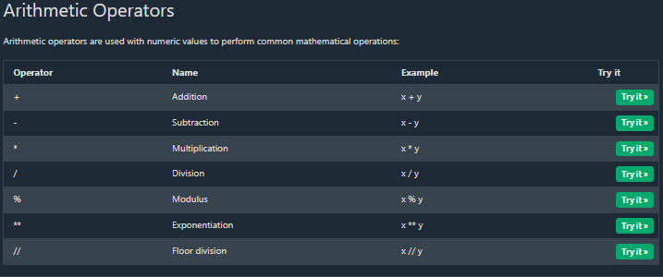
x = 15
y = 4
print(x + y)
print(x - y)
print(x * y)
print(x / y)
print(x % y)
print(x ** y)
print(x // y)

x = 12
y = 5
print(x / y)

x = 12
y = 5
print(x // y)

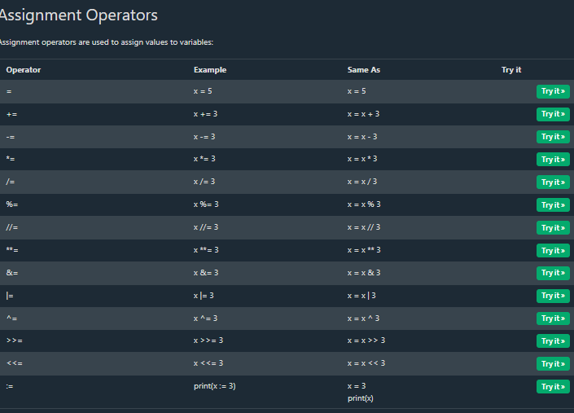
numbers = [1, 2, 3, 4, 5]
if (count := len(numbers)) > 3:
print(f"List has {count} elements")
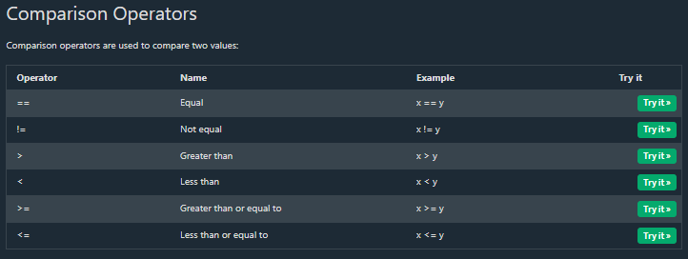

x = 5
y = 3
print(x == y)
print(x != y)
print(x > y)
print(x < y)
print(x >= y)
print(x <= y)
x = 5
print(1 < x < 10)
print(1 < x and x < 10)

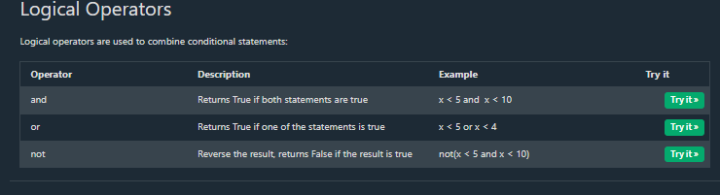

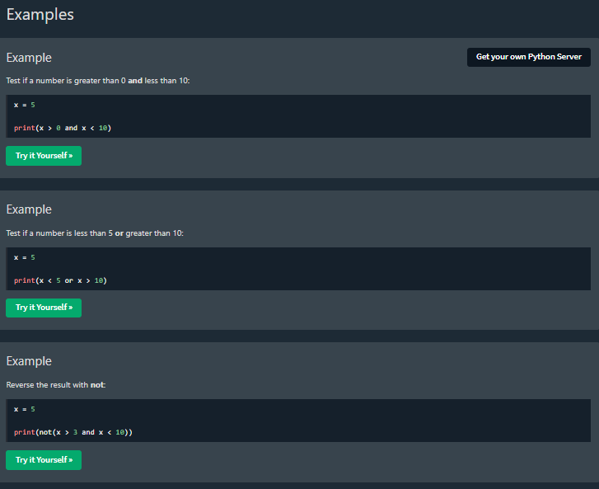

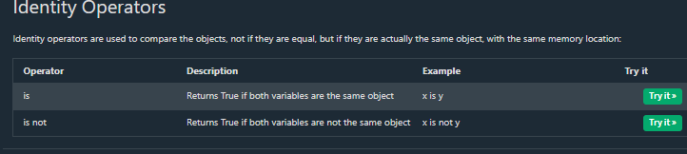
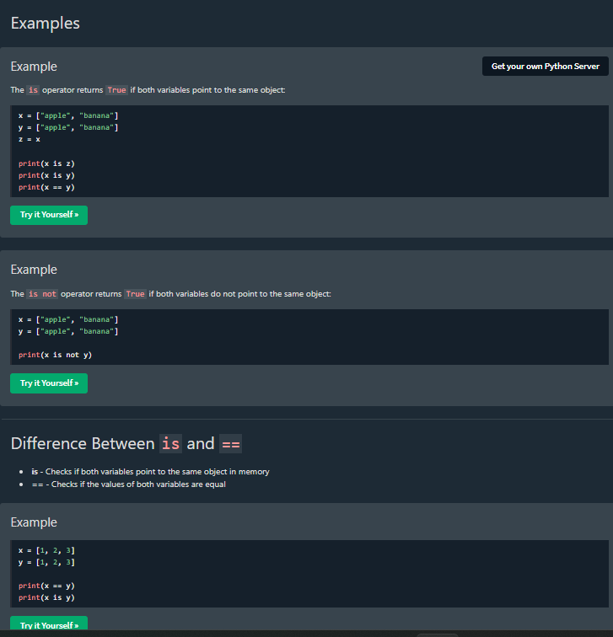
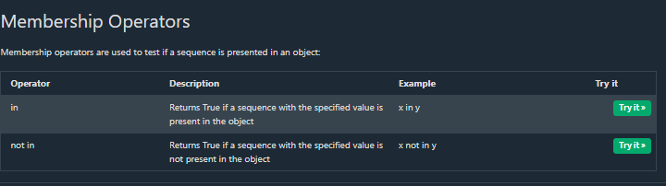

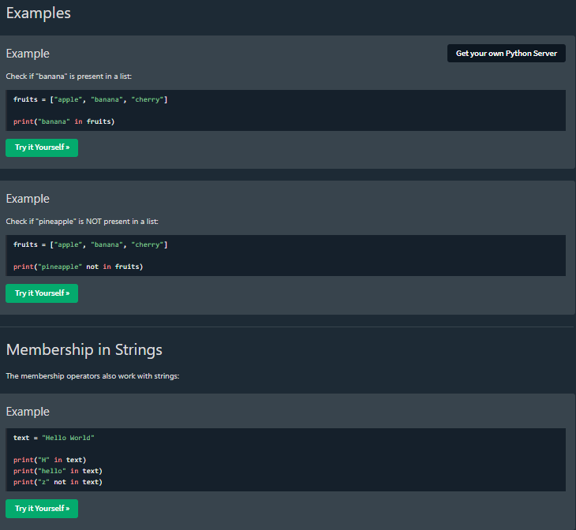
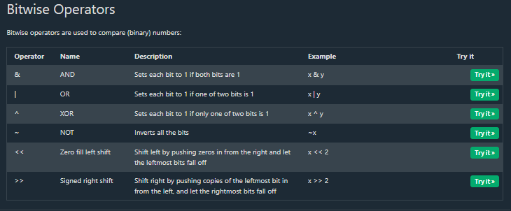
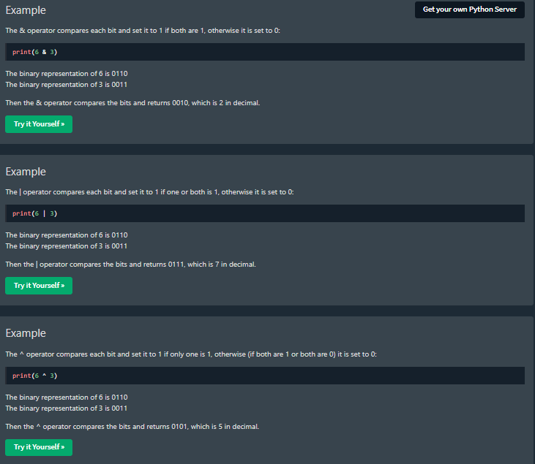

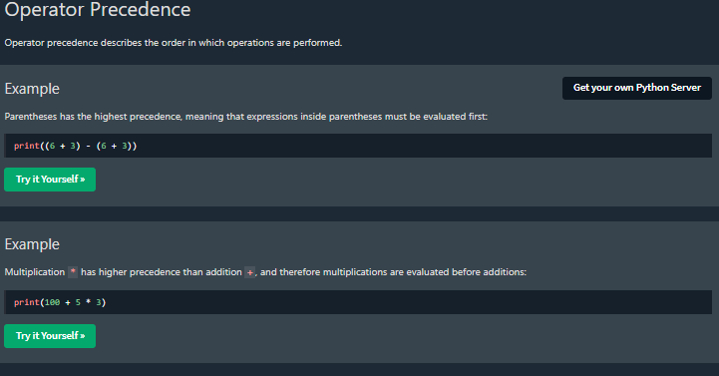
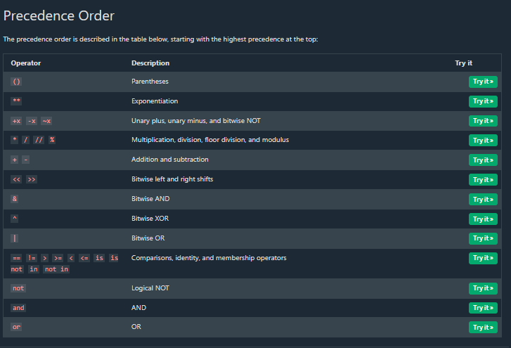

LISTS
mylist = ["apple", "banana", "cherry"]
thislist = ["apple", "banana", "cherry"]
print(thislist)

thislist = ["apple", "banana", "cherry", "apple", "cherry"]
print(thislist)
thislist = ["apple", "banana", "cherry"]
print(len(thislist))

list1 = ["apple", "banana", "cherry"]
list2 = [1, 5, 7, 9, 3]
list3 = [True, False, False]

list1 = ["abc", 34, True, 40, "male"]

mylist = ["apple", "banana", "cherry"]
print(type(mylist))

thislist = list(("apple", "banana", "cherry")) # note the double round-brackets
print(thislist)

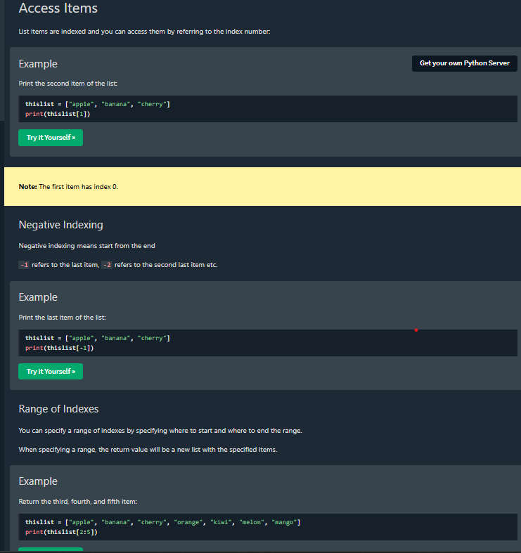
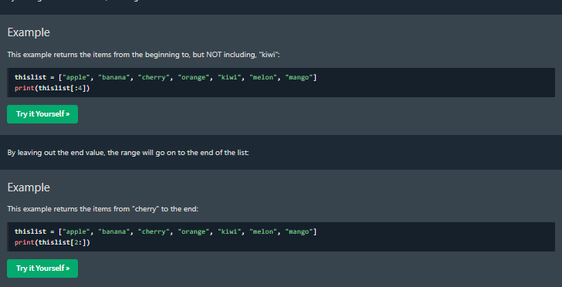
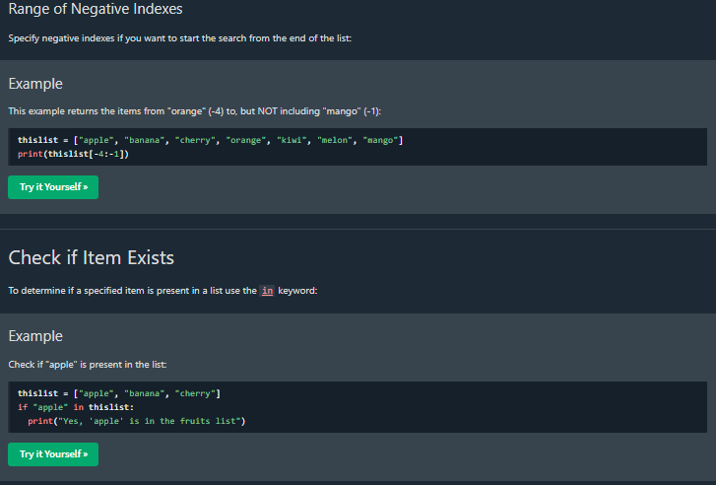

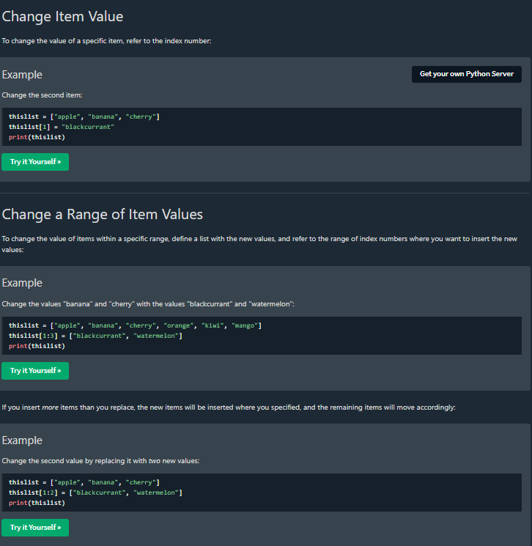
thislist = ["apple", "banana", "cherry"]
thislist[1:3] = ["watermelon"]
print(thislist)
thislist = ["apple", "banana", "cherry"]
thislist.insert(2, "watermelon")
print(thislist)
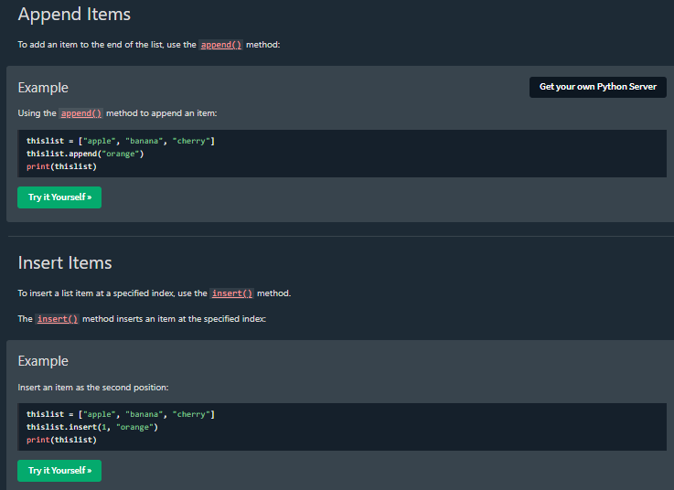
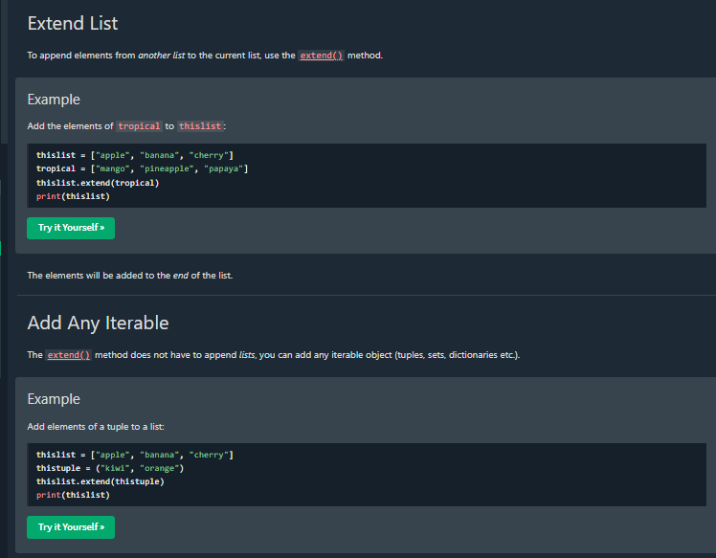

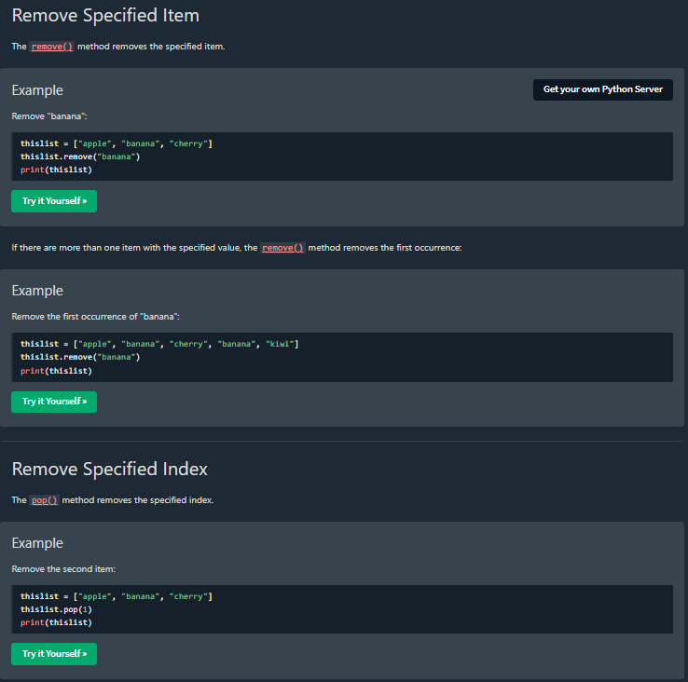
TUPLES
thistuple = ("apple", "banana", "cherry")
print(len(thistuple))

thistuple = ("apple",)
print(type(thistuple))
#NOT a tuple
thistuple = ("apple")
print(type(thistuple))

tuple1 = ("apple", "banana", "cherry")
tuple2 = (1, 5, 7, 9, 3)
tuple3 = (True, False, False)

tuple1 = ("abc", 34, True, 40, "male")

mytuple = ("apple", "banana", "cherry")
print(type(mytuple))

thistuple = tuple(("apple", "banana", "cherry")) # note the double round-brackets
print(thistuple)

thistuple = ("apple", "banana", "cherry")
print(thistuple[1])

thistuple = ("apple", "banana", "cherry")
print(thistuple[-1])

thistuple = ("apple", "banana", "cherry", "orange", "kiwi", "melon", "mango")
print(thistuple[2:5])

thistuple = ("apple", "banana", "cherry", "orange", "kiwi", "melon", "mango")
print(thistuple[:4])

thistuple = ("apple", "banana", "cherry", "orange", "kiwi", "melon", "mango")
print(thistuple[2:])

thistuple = ("apple", "banana", "cherry")
if "apple" in thistuple:
print("Yes, 'apple' is in the fruits tuple")

x = ("apple", "banana", "cherry")
y = list(x)
y[1] = "kiwi"
x = tuple(y)
print(x)

thistuple = ("apple", "banana", "cherry")
y = list(thistuple)
y.append("orange")
thistuple = tuple(y)

thistuple = ("apple", "banana", "cherry")
y = ("orange",)
thistuple += y
print(thistuple)

thistuple = ("apple", "banana", "cherry")
y = list(thistuple)
y.remove("apple")
thistuple = tuple(y)

thistuple = ("apple", "banana", "cherry")
del thistuple
print(thistuple) #this will raise an error because the tuple no longer exists

fruits = ("apple", "banana", "cherry")
(green, yellow, red) = fruits
print(green)
print(yellow)
print(red)

fruits = ("apple", "banana", "cherry", "strawberry", "raspberry")
(green, yellow, *red) = fruits
print(green)
print(yellow)
print(red)

fruits = ("apple", "mango", "papaya", "pineapple", "cherry")
(green, *tropic, red) = fruits
print(green)
print(tropic)
print(red)

thistuple = ("apple", "banana", "cherry")
for x in thistuple:
print(x)

thistuple = ("apple", "banana", "cherry")
for i in range(len(thistuple)):
print(thistuple[i])

thistuple = ("apple", "banana", "cherry")
i = 0
while i < len(thistuple):
print(thistuple[i])
i = i + 1

tuple1 = ("a", "b" , "c")
tuple2 = (1, 2, 3)
tuple3 = tuple1 + tuple2
print(tuple3)

fruits = ("apple", "banana", "cherry")
mytuple = fruits * 2
print(mytuple)

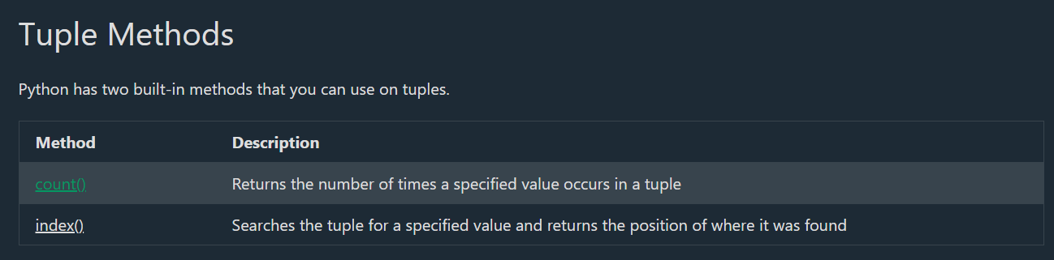

thistuple = (1, 3, 7, 8, 7, 5, 4, 6, 8, 5)
x = thistuple.count(5)
print(x)

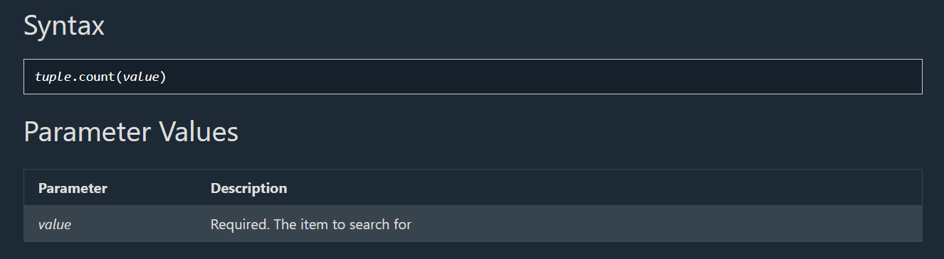

Index () method
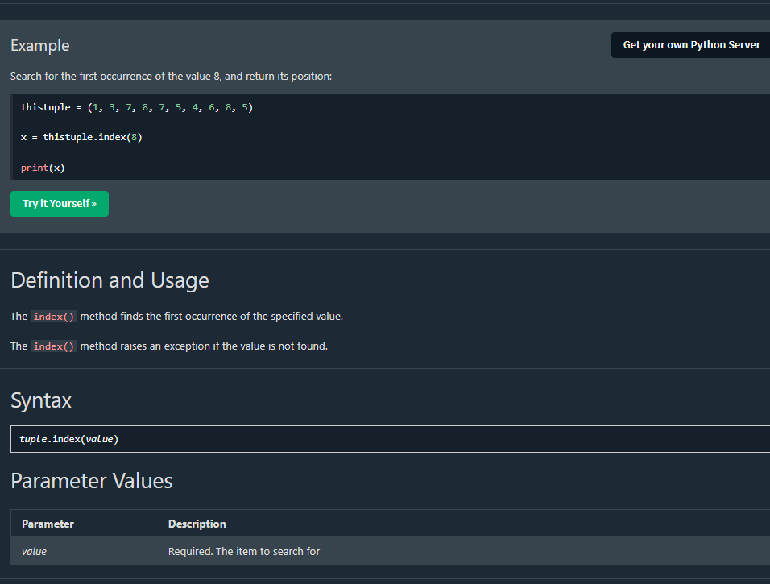

SET METHODS
